**Project Development Phase - Delivery Of Sprint-2**

|  |  |
| --- | --- |
| Team ID | PNT2022TMID40047 |
| Project Name | Smart Waste Management System For    Metropolitan Cities |

**System Architecture:**

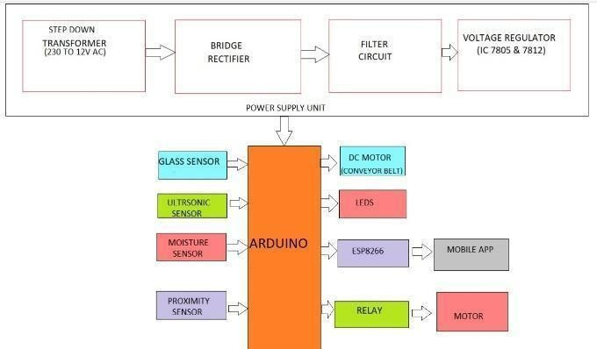

Figure (i) illustrate the overall system architecture module. Inlet, Split rollers, Pipeline system, Dihydrogen monoxide outlet system exhaust System chained conveyor belt, Incinerator, Solar panel, Brushes, Arduino Uno microcontroller, IR Sensor, Ultrasonic Sensor, Moisture Sensor, Glass Detector sensor, Inductive proximity Sensor, Node-MCU ESP8266, Wrapper,3 chambers for dihydrogen monoxide-2 for contaminant dihydrogen monoxide 1 for pristine dihydrogen monoxide, Thermo engenderer and Electrodes, ECU board, Breadboards, Jumper wires, OLED Exhibit, LED lights, DC motor is the few main components utilized for making the module.

**Components:**

* **Wrapping**
* **Incinerator**
* **Conveyer belt**
* **Pipeline system & Sensor**